908 News  NALC Branch 908  AFL-CIO  PO Box 1223  Blackwood, NJ 08012 | Bill Revak Branch 908  South Jersey Letter Carriers  Atco, Barrington, Bellmawr, Berlin, Blackwood, Bridgeton, Clayton, Deptford, Egg Harbor City, Gibbsboro, Gibbstown, Glassboro, Glendora, Gloucester, Haddon Hts., Hammonton, Lawnside, Magnolia, Mantua, Maple Shade, Marlton, Mt. Ephraim, National Park, Paulsboro, Penns Grove, Pennsville, Pitman, Riverton, Runnemede, Salem, Sewell, Somerdale, Stratford, Swedesboro, Voorhees, Wenonah, Westville, Williamstown, Woodbury, Woodstown |  | Return Service  Requested
 |  | 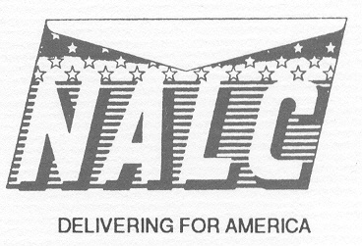
Newsletter Com: Litty, Lipski, Graff Ph: 906-2838 Fax: 227-0516 www.nalcbranch908.com October 2024

PRESIDENTS REPORT
Well, it appears we have a tentative agreement on a new contract. I don’t have any details as of this printing, but hopefully by our regular meeting this month, I will have the details. The Business Agent is attending a meeting on October 8-9 to discuss the details with the Executive Council and will let us know what it contains as soon as he returns. I will also be attending a Committee of Presidents meeting on October 21st, so I am sure there will be a lengthy discussion on all the particulars contained in this tentative agreement. Hopefully, the wait was worth it, and we can now move on to what lies ahead for everyone, as there will be a lot of things changing in the near future.
If we have a tentative agreement, just to let everyone know who may not understand the process, the agreement will be sent out to the membership for their approval before it becomes official, so don’t be upset if there are things you may not like. The membership is the controlling body, and if they don’t like it, they can reject it. Hang in there for the details and then we can all decide how we did with the long and exhausting wait, and whether to accept the Executive Councils recommendation.
As for our branch, the next order of business will be a merger vote at this month’s meeting with Branch 4623 out of Clementon. We read a resolution at last month’s meeting that was overwhelmingly approved with regard to this merger, and we will begin the formal process of completing this merger by discussing and voting on it at this month’s meeting. Please come out and voice your opinion or concerns you may have with this merger. We all agree it will be a great partnership and a win-win for both branches.
The next issue that may be surfacing is the opening of the S&DC in Vineland. It doesn’t appear any of our offices are slated to go in there at this time, but there is a rumor that Millville may be the first office to go in there. Nothing has been made official, but it appears things are starting to move down there. We also are hearing that Bellmawr will be slated for an S&DC sometime, possibly next year. I will keep everyone updated as I get more information.
We finally got some long-awaited news for two of our carriers who were CCA’s, and whose dates were incorrect in their being converted to career. After filing grievances, we finally got them converted with their proper dates being fixed and are in the midst of getting them all the back pay and benefits restored for the dates they should have been converted and missed out of the fruits of being career. I wish we could have gotten this fixed faster, but the process takes what it takes and can be very frustrating for those affected. I always say if you have been wronged, we will get it fixed for you, even if it takes time. The grievance procedure works, even though it may take some time to get the results we are looking for.
Next, we are looking to get a rally together with all our New Jersey branches regarding the carrier assaults occurring throughout our country and area. The Enough is Enough movement, which is going on in other parts of the country, we would like to become part of as well. As soon as I get more information, I will let everyone know when it will happen.

Next, open season will be here next month, so please start to look for information in the mail for the latest news on what we will all have to do this year. Any questions feel free to reach out to me or George Greenwood, our HB officer, for anything you might not be sure of.
Lastly, I want to thank all those members who came out to last month’s meeting. It was nice to see a nice turnout, and hopefully, the trend will continue going forward. I always say knowledge is power, and if you can get a little something at our meeting to take back with you, then it was worth the trip. See you at this month’s meeting. Gary DiGiacomo – President
WE VALUE YOUR OPINION; WE WANT TO HEAR FROM YOU
Welcome everyone to the fall season, this month and the months moving forward. I am going to ask you the membership to reach out to me. I would like to find out any issues that you may be having, especially an office wide issue or questions. I will answer each and every one of you personally, as well through this article monthly. As we know asking management in your office a contractual question is most likely to lead to the wrong answer. So, bring it to us your representatives, let us explain whatever issue or question you may have. I sure hope to hear from members with the hope of helping you deal with workroom floor situations. Also don’t forget we are fast approaching daylight savings time as you may have noticed it getting dark earlier and earlier every day. I wrote about this subject last year so I would like to go over this again. The most frequent question this time of the year is “do I have to work in the dark”. The simplest answer is yes, I will explain to try and help understand our responsibility. M-00483 STEP4 States: “September 26, 1980, normally letter carriers deliver mail during daylight hours; however, there is no contractual provision which would preclude management from assigning carriers to deliver mail in other than daylight hours.” Simply put management can assign you work that could occur in the dark. If this is the case, we as letter carriers should understand that safety is on us. Meaning if it is dark and the delivery you are attempting to make is not properly lit and you feel you could hurt yourself attempting to deliver, you must determine whether not to deliver. I would strongly recommend in this situation that you contact the office prior to return to inform the supervisor of the mail being returned and why. This is not to say an entire street can’t be delivered, this is a house-to-house determination. If driving curbside, we do not recommend any interior lights on while in motion. Once you return to the office always inform the supervisor again present the mail and request PS Form 1571 delayed mail report, make sure you get a copy, and it’s signed by supervision. Do not just choose to bring back mail and say unsafe, be prepared to explain each address. Management’s main concern is getting the mail delivered, that’s all. We must be aware of the safety factors you simply will not be given guidance from management on this. Daylight Savings time is 11/3/24 through 3/9/25. Always remember their bad day is not yours, they also have a responsibility to follow the rules. Stay Strong, Strength in Numbers, I look forward to hearing from you. Executive Vice President Shawn McBride (856)649-9317

ANGEL TREE
Brothers and Sisters please take the time to vote in the upcoming election on November 5, your vote counts no matter what party you are affiliated with. About 6 years ago I got members of our branch involved in the Angel Tree for underprivileged children. In those 6 years we provided gifts to approximately 120 kids. I am happy to say Branch 908 will be participating in the Angel Tree again this year. The way it works is, tags are placed on the tree representing these children’s wishes. Donors pick a tag from the tree and then shop for the gift for the child selected. If any member is interested in participating contact Vice -President Mike Powell @ 856-906- 2026. If you believe every child deserves a Merry Christmas, please help! I want to encourage all our active members, retired members and CCA’s to try to attend our monthly meetings. It is not only your chance to get valuable information on things happening in the branch but more importantly to ask questions or voice your concerns to your elected officers. You can also grab a bite to eat, have a beverage of your choice and meet and mingle with new and old friends. If any active member, CCA or retired member needs my aid on any issue please contact me anytime at (856) 906-2026 or 908vp@comcast.net. PROUD TO BE UNION. Mike Powell-Vice President

NEXT MEETING

The next regular monthly meeting of the Branch will be held on Wednesday, October 16th @ 8 pm, at the American Legion Hall, 502 Colonial Ave., Woodbury. The regular monthly meetings of the Branch are held on the Third Wednesday of each month @ 8 p.m. The Executive Board and Shop Steward meetings are held on the 2nd Wednesday of the month. The Executive Board meets @ 7:30 pm, and the Shop Stewards @ 8 pm. The next meeting of the Executive Board and Shop Stewards will be on Wednesday, October 9th @ 7:30 and 8pm respectively.

ATTENDANCE PRIZE NOW AT $175

Had he been in attendance at the regular monthly meeting of the Branch on Wednesday, September 18^{th,} Keith Van Deventer, a member out of the Stratford Office, would have been the recipient of the $150 attendance prize. The prize now increases to $175 and will increase $25 per meeting, up to a maximum of $250, until a member in attendance has their name drawn.

CHANGES COMING IN OPEN SEASON

Hello folks. Hope all's well. Things are beginning to happen with the upcoming changes so let's just get started here. First the Bill Revak Br. 908 Optical account. Any member of Br. 908 in good standing who would like your annual $20 reimbursement for optical expenses simply mail me a paper copy of your expense receipt with your name, address, and office/retired to me at George Greenwood HBR, 1083 Chews Landing Rd., Laurel Springs, NJ 08021. Remember it's for one $20 reimbursement per year per member/or qualified dependent. As I was saying at September's general meeting the new PSHB System is slowly, but surely rolling out. These changes in open season are for all active, and retired career carriers, and dependents. Not CCA's until you convert to career. Keep a close eye on all mail coming from USPS, and OPM. Open Season will run from Monday Nov. 9th until Monday December 9th. Notifications are beginning to arrive by mail from both organizations. I would suggest you start becoming familiar with a couple pages online. First, and foremost where most all of your efforts should be directed to is... https://www.opm.gov/healthcare-insurance/pshb/ …..OPM.gov is where most information, on how, when, and where to complete the process of changing from fehbp to the new USPS PSHB, and a comparison chart can be found there also. I'd recommend familiarizing yourself with this page for now as more, and more information begins to arrive by mail. Watch your mail very closely. Some other pages include https://www.keepingposted.org/postal-service-health-benefits.htm (You can also receive information and updates by signing up for text messaging notifications by texting “PSHBP” to 39369) And of course the best HBP on the market which is the NALC HBP information located at https://www.nalchbp.org/news/pshb-2024-open-season Other Insurance and Benefits Programs Enrollment in a PSHB plan will not change availability of or enrollment in other insurance and benefits programs, including: (These will still be done as in the past ) Federal Employees Dental and Vision Insurance Program (FEDVIP) Federal Employees’ Group Life Insurance (FEGLI) Long Term Care Insurance Program (FLTCIP) As all this begins to take shape please watch for all mail, email, etc... and read all mail from USPS, opm.gov, various insurance companies, and information resources listed above. Also, as the information becomes more available, please always feel free to contact me with any questions, or concerns regarding all the above. George Greenwood HBR 856-304-8665. Be safe brother and sisters. See you at the next meeting. -George Greenwood, HBR

MANAGEMENT DROPPED THE BALL (Part2)

On July 11th in the morning at The Camden Annex, I gathered up all our employees from our five 908 offices to do a Safety Talk. As me and Mike Powell (Shop Steward) started to share the traumatic ordeal that hit so close to home for one of our employees, somebody is hurting. The "raw" information we immediately disclosed had a huge impact on the mental health issues side. Think about it, 1 person, or all of the workers in the 908 zone alone (just by the union doing our Safety Talk) instantly felt anxiety and or stress. Mike Powell said, "Please pay close attention to what is going on in the streets and on your routes daily". Also, I said, "No matter if it is one person or a group, please give up what they want. Your life is more precious than any package, check or bill". After the union addressed the employees, I asked the newly installed Postmaster, (Balvinder Singh-Minhas) to say a few words. The Postmaster said and I quote, "No Mr. Lecky and Mr. Powell... I have nothing". During that morning gathering, I noticed that a familiar group was missing in attendance (I will get back to that in a few). The following day on Friday, July 12th, I saw the Postmaster in the morning walking through our zone. I approached him and said the following, "The situation that happened on Wednesday is still raw to most, if not all of us. I think you need to contact E.A.P." Mr. Balvinder said he would contact them. 11 days later, there wasn't a trace of a visit from a professional counselor or therapist. The day was to be our July 23rd Safety Meeting. The guests include representatives in all crafts in the building, The Postmaster and a special appearance from The POOM (Post Office Operations Manager). As we breezed through accident updates, old business and new business. Like a tea kettle sounding off when the water on the stove reached a boiling point, I immediately dived right in and addressed this topic as last on the meeting's agenda. I turned right to the Postmaster and said, "You dropped the ball on this!". "During the morning of July 11th why wasn't E.A.P. (Employee Assistance Program) present to address the employees?” I asked. The Postmaster said to me, "Ozzie, I had a plan to do something". Something, really? Try nothing! Here is a fact: whether you like it or not, this crime happened under your watch! I said to Mr. Balvinder, "If I was the lead management head in a 100-route building and this tragedy happened I would have been on the phone minutes after the employee was assaulted". I would have been on the phone saying the following to The POOM or E.A.P., "Help! We need immediate counseling/therapy, something for our workers because we are in a crisis! That is why we have E.A.P., the program is for us...The Letter Carrier, Clerk, Mail Handler, VOMA and Custodian". I switched topics and asked, "Mr. Balvinder, did you even reach out to check on the employee to see how that person was doing?" Because of all the notes I gathered from this meeting, I don't want to leave anything out for "you" the members. I will conclude this article next month. Again, I apologize. Also, I will mention all our LCPF contributors for September and October in next month's newsletter. I hope to see you all at October 16th's meeting In Solidarity,
Ozzie Lecky - Letter Carrier Political Fund Chairman
*(By making a contribution to the LCPF, you are doing so voluntarily with the understanding that your contribution is not a condition of membership in the NALC or of employment by the USPS, nor is it part of union dues. You have a right to refuse to contribute without any reprisal. The LCPF will use the money it receives to contribute to candidates for federal office and undertake other political spending as permitted by law. Your selection shall remain in full force and effect until cancelled. Contributions to the LCPF are not deductable for federal income tax purposes. Federal law prohibits the LCPF from soliciting contributions from individuals who are not NALC members, executive and administration staff, or their families.)

HOPS FOR HOPE

The Branch is hosting a fundraiser for the Muscular Dystrophy Association (MDA) at the Double Nickel Brewery on Sunday, Oct. 13th from 2–5 PM. See your shop steward or call/text April 856-885-1451 or Jason @ 856-503-5007 for more info and tickets. Tickets will also be available at the regular monthly meeting. Tickets are $25 each. Our sincerest appreciation to some of our donors: Wawa, Chick Fila of Sicklerville, Longwood Gardens, Texas Roadhouse of Sicklerville, Dave & Busters, TGIFridays, Top Golf, Morey’s Beachfront waterparks, Pinspiration with more to come.

KID’S CHRISTMAS PARTY

Save the date! Our annual kids’ Christmas party will be Sunday December 8^{th,} 12-3pm. There will be food, games, holiday crafts, an American made toy for each child, and a visit with Santa!
PRE-ARBITRATION SETTLEMENT
Voorhees- The Letter of Demand issued to grievant in the amount of $539.14 for allegedly damaging a scanner is hereby Rescinded and Expunged.
STEP B DECISIONS
Deptford- Management violated Article 11 of the National Agreement and LMOU item #13, when they forced a full-time regular carrier to work their designated holiday when they did not maximize CCA’s in the facility. As a remedy, two carriers with the highest seniority shall receive an additional 50% premium for all hours worked on May 25, 2024.
Williamstown- Management violated a pre-arbitration settlement regarding the handling of secondary address mail in the DPS. As a remedy, carriers will be permitted to retrieve and case secondary address mail from the DPS in the office until the issue is resolved.
Sewell- Management violated Article 7 and the Conversion memo when they failed to convert a CCA to PTF after reaching 24 months of relative standing. As a remedy, the CCA will be converted to full-time regular career status retroactive to August 26, 202. Also, the employee will be made whole for hours and benefits that he missed out on due to this error.
Gibbstown-Management violated Article 41 and the Memo on converting, when they failed to properly convert the correct PTF to Full-time in this installation. As a remedy, the carrier will have her career regular status made retroactively to September 9, 2023, with rank #1. Additionally, she will have the choice of route 66001 or an unassigned regular position, whichever she chooses. She will also be made whole for all lost wages and benefits.
MERGER RESOLUTION

Please be advised that there will be a Merger Resolution Voted on at this month’s general membership meeting, Oct. 16th, regarding Clementon Branch 4623’s possible merger with our branch.

NEWLY CONVERTED EMPLOYEES
If you haven’t been to orientation prior to or at the start of your conversion let your steward or one of the officers know. This is different from your original orientation when you were hired. You have 60 days to make changes to your health insurance. This also puts you in the category of having to make a selection during open season. (See above article) Enrolling in TSP is also highly recommended. At least put in 5%. USPS matches dollar for dollar up to 3% and $0.50 on the dollar up to 5%. This is an easy way to save for your retirement, and if needed you can borrow from it at a much lower interest rate than the going rates. If you’re unsure how to do this reach out to one of the officers and we can direct you to someone who can help.

CCA’S

There are gently used uniforms at the union hall. Check them out after the meeting Oct 16th, 8pm.

OPEN SEASON

Runs from November 9th through December 9th.

PENALTY EXCLUSION

Runs from November 30th through December 27th.

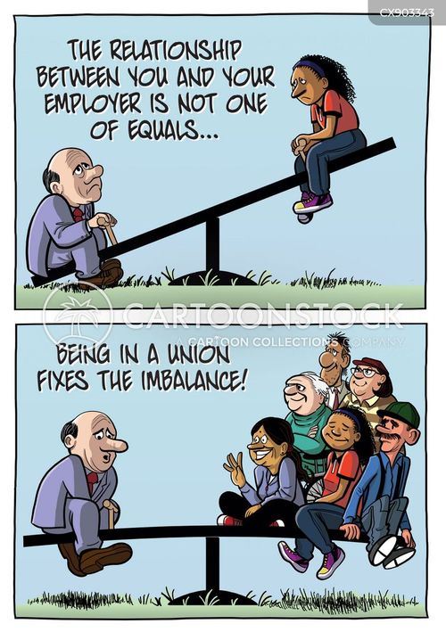
NON-UNION MEMBERS

- Walter Lyons-Hammonton
- Tyrone Johnson-Riverton
- Luis Luna-Williamstown
- Dawayne Sanders-Williamstown
- Paul Heil-Woodbury
- Lawrence Trimmer-Woodbury
- Mark Robinson-Swedesboro
- Gianna Giunta-Ruiz-Woodbury
- Nicole West-Stratford

Check us out on the web: www.nalcbranch908.com
And Facebook: NALC Branch 908
To submit photos to the website or original artwork for the newsletter email: Aprillitty@gmail.com

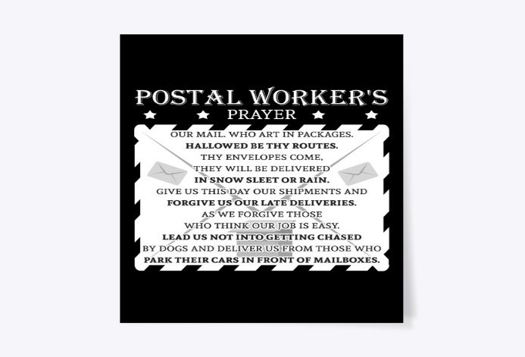

Branch Attorneys
Uliase & Uliase
106 White Horse Pike, Haddon Heights, NJ 08035
(856) 310-9002

